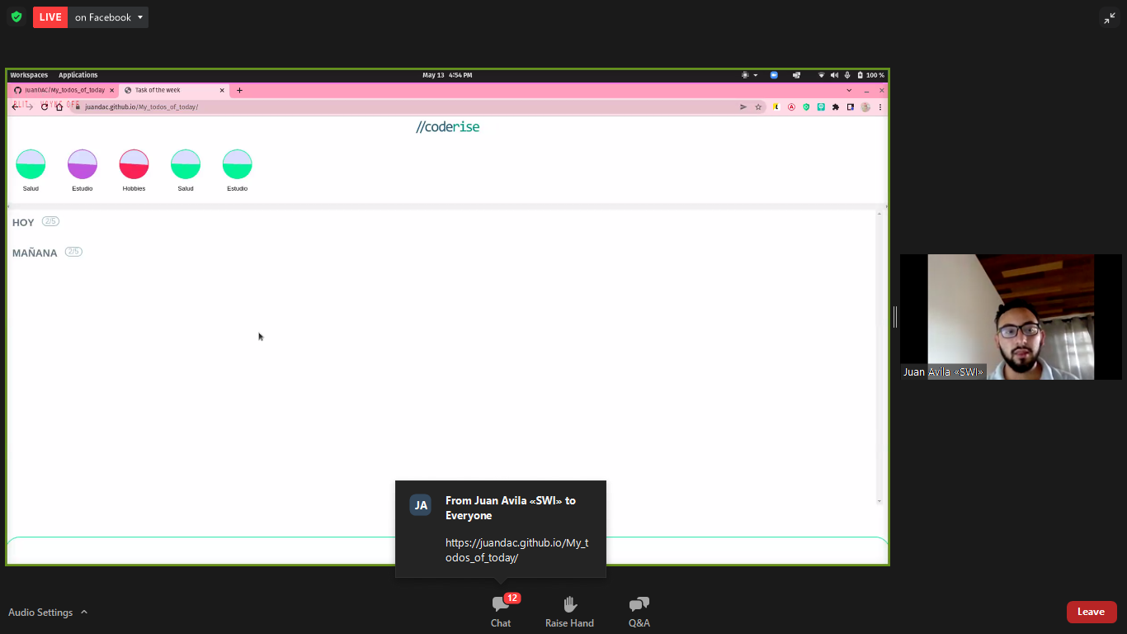

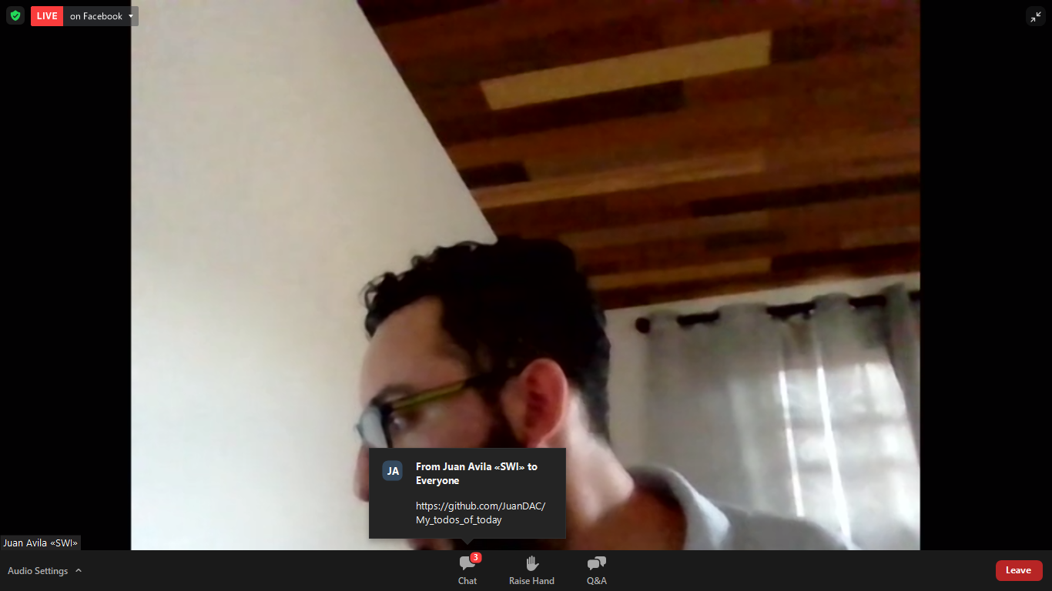

|  |
| --- |
| * { |
|  |

|  |
| --- |
| margin: 0; |
|  |

|  |
| --- |
| padding: 0; |
|  |

|  |
| --- |
| font-family: Arial, Helvetica, sans-serif; |
|  |

|  |
| --- |
| } |
|  |

|  |
| --- |
|  |
|  |

|  |
| --- |
| :root { |
|  |

|  |
| --- |
| --color-white: #fff; |
|  |

|  |
| --- |
| --color-black: #000; |
|  |

|  |
| --- |
| --color-orange: #ffa500; |
|  |

|  |
| --- |
| --color-text-second: #3b2a10; |
|  |

|  |
| --- |
| } |
|  |

|  |
| --- |
|  |
|  |

|  |
| --- |
| @font-face { |
|  |

|  |
| --- |
| font-family: Whopper; |
|  |

|  |
| --- |
| src: url(../fonts/FredokaOne-Regular.ttf); |
|  |

|  |
| --- |
| } |
|  |

|  |
| --- |
|  |
|  |

|  |
| --- |
| body { |
|  |

|  |
| --- |
| height: 100%; |
|  |

|  |
| --- |
| width: 100%; |
|  |

|  |
| --- |
| position: relative; |
|  |

|  |
| --- |
| } |
|  |

|  |
| --- |
|  |
|  |

|  |
| --- |
| .header { |
|  |

|  |
| --- |
| height: 140px; |
|  |

|  |
| --- |
| width: 100%; |
|  |

|  |
| --- |
| position: absolute; |
|  |

|  |
| --- |
| top: 0; |
|  |

|  |
| --- |
| left: 0; |
|  |

|  |
| --- |
| display: flex; |
|  |

|  |
| --- |
| align-items: center; |
|  |

|  |
| --- |
| justify-content: center; |
|  |

|  |
| --- |
| z-index: 10; |
|  |

|  |
| --- |
| } |
|  |

|  |
| --- |
|  |
|  |

|  |
| --- |
| .header-container { |
|  |

|  |
| --- |
| width: 95%; |
|  |

|  |
| --- |
| height: 80%; |
|  |

|  |
| --- |
| display: flex; |
|  |

|  |
| --- |
| justify-content: space-between; |
|  |

|  |
| --- |
| align-items: center; |
|  |

|  |
| --- |
| margin-top: -4rem; |
|  |

|  |
| --- |
| } |
|  |

|  |
| --- |
|  |
|  |

|  |
| --- |
| .icon { |
|  |

|  |
| --- |
| height: 100%; |
|  |

|  |
| --- |
| width: auto; |
|  |

|  |
| --- |
| } |
|  |

|  |
| --- |
|  |
|  |

|  |
| --- |
| .menu-item { |
|  |

|  |
| --- |
| color: var(--color-white); |
|  |

|  |
| --- |
| font-size: 20px; |
|  |

|  |
| --- |
| cursor: pointer; |
|  |

|  |
| --- |
| margin: 0 1rem; |
|  |

|  |
| --- |
| text-transform: uppercase; |
|  |

|  |
| --- |
| font-weight: 600; |
|  |

|  |
| --- |
| letter-spacing: 0.7px; |
|  |

|  |
| --- |
| cursor: pointer; |
|  |

|  |
| --- |
| position: relative; |
|  |

|  |
| --- |
| } |
|  |

|  |
| --- |
|  |
|  |

|  |
| --- |
| .menu-item::after { |
|  |

|  |
| --- |
| position: absolute; |
|  |

|  |
| --- |
| content: ""; |
|  |

|  |
| --- |
| height: 4px; |
|  |

|  |
| --- |
| width: 0; |
|  |

|  |
| --- |
| background-color: var(--color-white); |
|  |

|  |
| --- |
| bottom: -7px; |
|  |

|  |
| --- |
| left: 0; |
|  |

|  |
| --- |
| transition: all 0.5s; |
|  |

|  |
| --- |
| } |
|  |

|  |
| --- |
|  |
|  |

|  |
| --- |
| .menu-item:hover::after { |
|  |

|  |
| --- |
| width: 100%; |
|  |

|  |
| --- |
| } |
|  |

|  |
| --- |
|  |
|  |

|  |
| --- |
| .hero-section { |
|  |

|  |
| --- |
| height: 100vh; |
|  |

|  |
| --- |
| width: 100%; |
|  |

|  |
| --- |
| position: relative; |
|  |

|  |
| --- |
| overflow: hidden; |
|  |

|  |
| --- |
| } |
|  |

|  |
| --- |
|  |
|  |

|  |
| --- |
| .hero-section::after { |
|  |

|  |
| --- |
| content: ""; |
|  |

|  |
| --- |
| height: 120%; |
|  |

|  |
| --- |
| width: 40%; |
|  |

|  |
| --- |
| position: absolute; |
|  |

|  |
| --- |
| top: 0; |
|  |

|  |
| --- |
| right: 0; |
|  |

|  |
| --- |
| background-color: var(--color-black); |
|  |

|  |
| --- |
| z-index: -1; |
|  |

|  |
| --- |
| border-bottom-left-radius: 70% 100%; |
|  |

|  |
| --- |
| background-image: url(../img/Back.png); |
|  |

|  |
| --- |
| background-position: top right; |
|  |

|  |
| --- |
| filter: brightness(50%); |
|  |

|  |
| --- |
| } |
|  |

|  |
| --- |
|  |
|  |

|  |
| --- |
| .text-side { |
|  |

|  |
| --- |
| display: flex; |
|  |

|  |
| --- |
| justify-content: center; |
|  |

|  |
| --- |
| align-items: center; |
|  |

|  |
| --- |
| flex-direction: column; |
|  |

|  |
| --- |
| position: absolute; |
|  |

|  |
| --- |
| top: 50%; |
|  |

|  |
| --- |
| left: 150px; |
|  |

|  |
| --- |
| transform: translateY(-50%); |
|  |

|  |
| --- |
| } |
|  |

|  |
| --- |
|  |
|  |

|  |
| --- |
| .second-text { |
|  |

|  |
| --- |
| font-size: 46px; |
|  |

|  |
| --- |
| text-transform: uppercase; |
|  |

|  |
| --- |
| color: var(--color-text-second); |
|  |

|  |
| --- |
| font-weight: 600; |
|  |

|  |
| --- |
| margin-bottom: -20; |
|  |

|  |
| --- |
| } |
|  |

|  |
| --- |
|  |
|  |

|  |
| --- |
| .main-text { |
|  |

|  |
| --- |
| font-size: 150px; |
|  |

|  |
| --- |
| text-transform: uppercase; |
|  |

|  |
| --- |
| color: var(--color-text-second); |
|  |

|  |
| --- |
| font-family: "Whopper"; |
|  |

|  |
| --- |
| margin-top: 0; |
|  |

|  |
| --- |
| margin-bottom: 2rem; |
|  |

|  |
| --- |
| line-height: 120px; |
|  |

|  |
| --- |
| } |
|  |

|  |
| --- |
|  |
|  |

|  |
| --- |
| .button { |
|  |

|  |
| --- |
| padding: 20px 30px; |
|  |

|  |
| --- |
| color: var(--color-white); |
|  |

|  |
| --- |
| font-size: 18px; |
|  |

|  |
| --- |
| font-weight: 600; |
|  |

|  |
| --- |
| letter-spacing: 0.5px; |
|  |

|  |
| --- |
| text-transform: uppercase; |
|  |

|  |
| --- |
| background-color: var(--color-orange); |
|  |

|  |
| --- |
| text-decoration: none; |
|  |

|  |
| --- |
| border-radius: 40px; |
|  |

|  |
| --- |
| transition: 0.5s; |
|  |

|  |
| --- |
| } |
|  |

|  |
| --- |
|  |
|  |

|  |
| --- |
| .button:hover { |
|  |

|  |
| --- |
| background-color: transparent; |
|  |

|  |
| --- |
| border: 1px solid var(--color-orange); |
|  |

|  |
| --- |
| color: var(--color-black); |
|  |

|  |
| --- |
| } |
|  |

|  |
| --- |
|  |
|  |

|  |
| --- |
| .hamburguer { |
|  |

|  |
| --- |
| position: absolute; |
|  |

|  |
| --- |
| top: 50%; |
|  |

|  |
| --- |
| right: 200px; |
|  |

|  |
| --- |
| height: 70%; |
|  |

|  |
| --- |
| transform: translateY(-50%); |
|  |

|  |
| --- |
| z-index: 2; |
|  |

|  |
| --- |
| } |
|  |

|  |
| --- |
|  |
|  |

|  |
| --- |
| .fries { |
|  |

|  |
| --- |
| position: absolute; |
|  |

|  |
| --- |
| top: 45%; |
|  |

|  |
| --- |
| right: 200px; |
|  |

|  |
| --- |
| height: 70%; |
|  |

|  |
| --- |
| transform: translateY(-50%); |
|  |

}